1. Queries:
2. _fetch * from bruteforce limit 100

>>_agg count_unique $Country

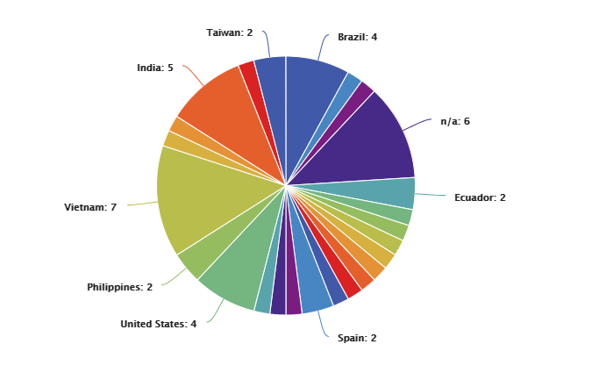

1. _fetch * from bruteforce where $Type=Wordpress limit 100

>>_agg count_unique $Organisation

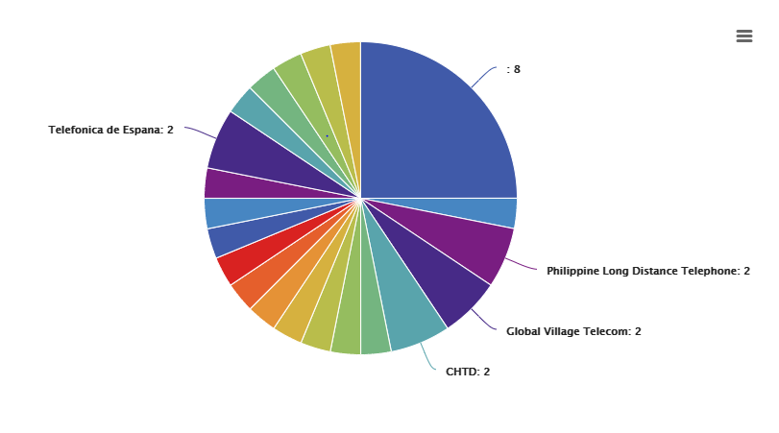

1. _fetch * from bruteforce limit 100>>_agg count_unique $Country

Chart Type : Geo Map

Country_Code Fields : $Country

Value : Count_Unique

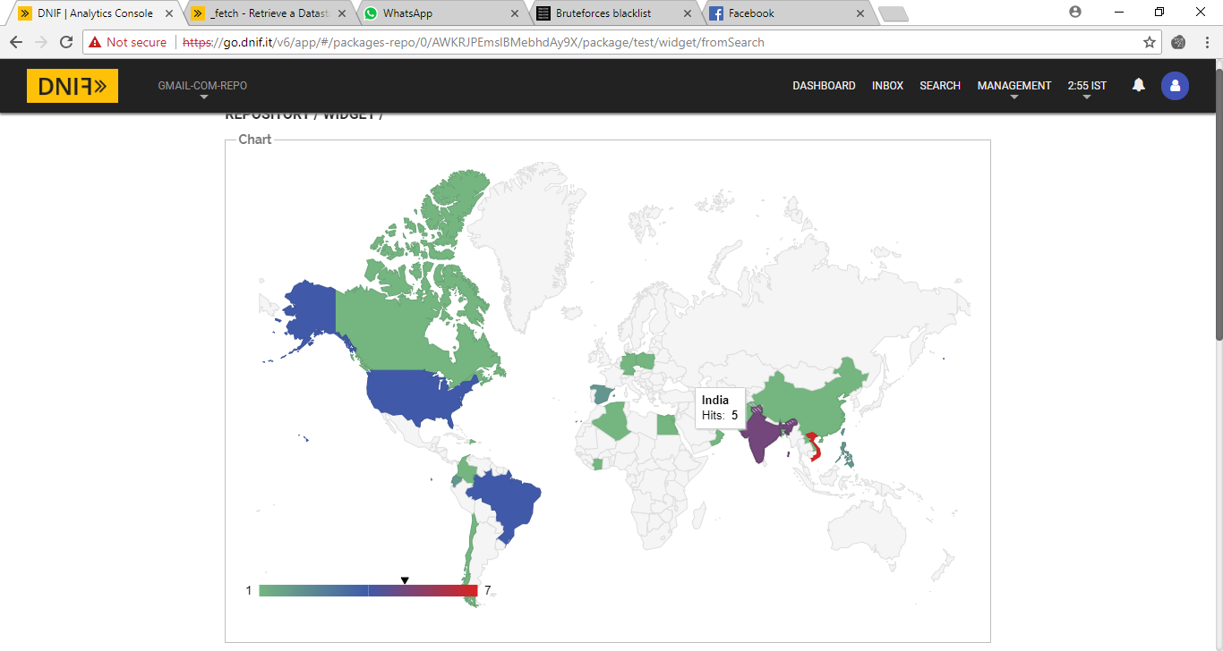

1. _fetch * from bruteforce limit 100

>>_agg count_unique $Organisation

>>_sort by $Organisation DESC

Line Chart:

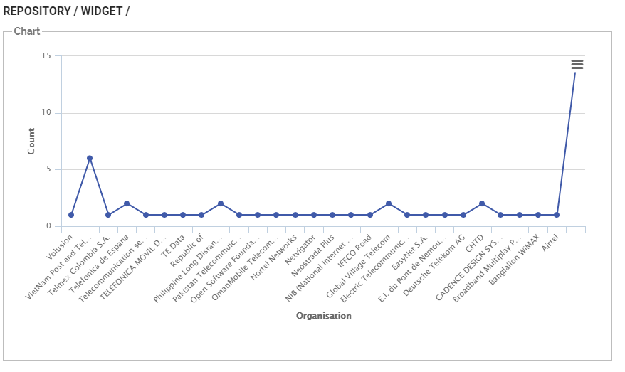

1. _fetch * from bruteforce limit 100

>> _agg max $Organisation

Result : Volusion

1. _fetch * from bruteforce limit 100

>> _agg max $Country

Result : n/a

7._fetch $IPAddress , $Country , $Organisation from bruteforce where $Country=India AND $Type=Wordpress AND $Date=03-05-2018 limit 100

>>_agg count_unique $IPAddress

8.

_fetch * from bruteforce AND $Duration=24h limit 100

>>_agg count_unique $Country

Cron job can be created using create workbook feature to run a particular query at particular time in dnif

Refer screenshot

https://dnif.it/docs/guides/tutorials/how-to-create-workbooks.html

